**GANADOR**

0 - 2

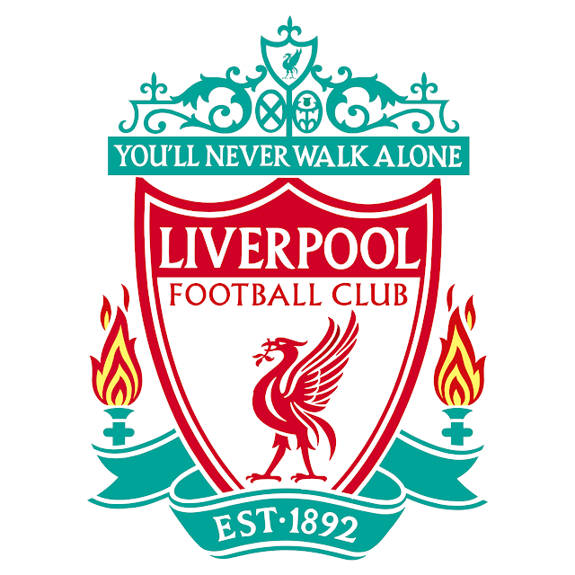

LIVERPOOL



TOTTENHAM

**FINAL**



TOTTENHAM

2 - 3

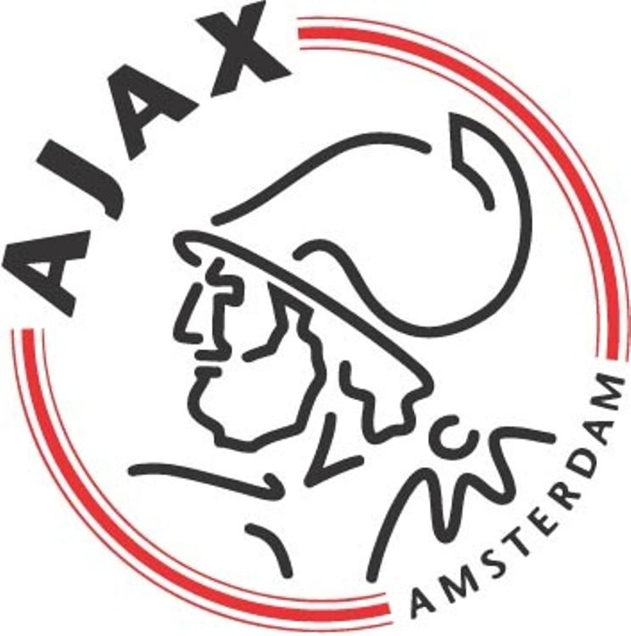

AJAX



BARCELONA

4 - 0



LIVERPOOL

**SEMIFINAL**

|  |  |  |
| --- | --- | --- |
| Barcelona | 3-0 | M. United |
| Juventus | 1-2 | Ajax |
| M. City | 4-3 | Tottenham |
| Oporto | 1-4 | Liverpool |

**CUARTOS**

**OCTAVOS**

**CHAMPIONS LEAGUE**

|  |  |  |
| --- | --- | --- |
| M. United | 0-2 | PSG |
| Roma | 2-1 | Oporto |
| Tottenham | 3-0 | B. Dortmund |
| Ajax | 1-2 | Real Madrid |
| Lyon | 0-0 | Barcelona |
| Liverpool | 0-0 | Bayern |
| Atlético | 2-0 | Juventus |
| Schalke | 2-3 | M. City |